Blog 2 (Australian Authors) April 2026
Image alt text me keyword, title and description blog wala use hoga. Main heading H1 hogi yani blog title and subheading h2, and others h3
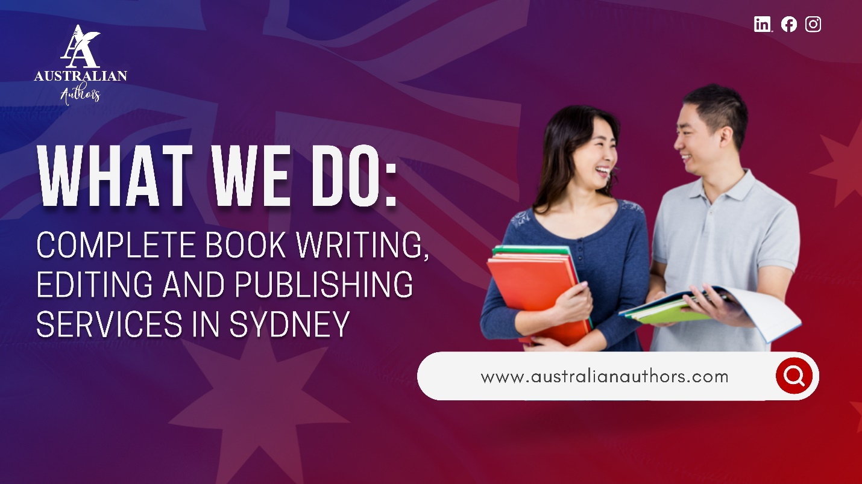
Are you an Australian writer sitting on a finished manuscript, wondering how to turn it into a real book that readers will love? You are not alone. Many talented authors in Sydney and across the country face the same question. That is exactly why we created book writing and publishing services Sydney that take the stress out of the process and deliver professional results.
At Australian Authors, we offer complete, end-to-end support under one roof. Whether you need help writing your book from scratch or simply polishing and publishing what you already have, we handle everything so you can focus on what you do best: telling your story.

Our Full Range of Book Services in Sydney
We know the Australian publishing world can feel overwhelming. Traditional routes often take years, while going solo leaves many authors stuck on formatting, design, or marketing. That is where our book writing and publishing services Sydney make the difference.
Here is what we actually do for you:
- Ghostwriting and Professional Writing Support:
Some authors have a clear idea but struggle to get words on the page. Others need a full manuscript written. Our experienced ghostwriters and writers craft compelling fiction, non-fiction, memoirs, and business books in your unique voice.
- Editing and Proofreading:
Even the best manuscripts benefit from fresh eyes. We provide developmental editing, copyediting, and final proofreading to ensure your book is polished, error-free, and ready for readers.
- Book Cover Design:
Your cover is the first thing buyers notice on Amazon AU or Booktopia. Our designers create professional, genre-appropriate covers that stand out and help your book sell.
- Formatting for Print and eBook:
We format your book perfectly for Amazon KDP, IngramSpark, and Australian distributors so it looks flawless in both paperback and digital formats.
- Full Self-Publishing and Distribution:
We manage ISBNs through Thorpe-Bowker, upload to all major platforms, and set up distribution so your book reaches bookstores and online retailers across Australia.
- Book Marketing and Promotion:
Writing the book is only half the journey. We help with launch strategies, Amazon AU optimisation, social media promotion, and author website creation to give your book the best chance of success.

Why Australian Authors’ Book Services Work So Well
Sarah, a busy teacher from Sydney’s Northern Beaches, came to us with a completed memoir. She had no idea where to start with editing or design. Within six months, her book was live on Dymocks and Amazon AU, and she received her first royalty payment. Stories like Sarah’s happen every month because we keep the process simple and local.
We base our team right here in Sydney. This means faster communication, quicker turnaround times, and a genuine understanding of the Australian market. You never have to chase overseas providers or wonder about time zones.

How Our Services Fit Every Author’s Needs
No two writers are the same. That is why our book writing and publishing services Sydney stay flexible:
- First-time authors often need the full package from idea to published book.
- Experienced writers may only want professional editing and cover design.
- Busy professionals frequently choose our ghostwriting option so they can share their expertise without spending months writing.
Whatever your situation, we tailor the support to you.

Practical Checklist – Which Services Do You Need Right Now?
- Your manuscript is complete but needs professional editing
- You want a custom book cover that sells on Booktopia and Amazon AU
- You need clean formatting for both print and eBook
- You would like help with ghostwriting or rewriting sections
- You want full self-publishing support, including Thorpe-Bowker ISBNs and distribution
- You are ready to promote your book effectively in the Australian market
Tick even two boxes, and you will benefit from speaking with our team.

Common Questions Australian Authors Ask Us
“Do I have to do everything myself?” No. You can hand over as much or as little as you like. Many authors choose our full-service option and simply review each stage.
“How long does it take?” Timelines vary, but most authors see their book published within 3 to 6 months when they work with us, much faster than traditional publishing routes.
“Is self-publishing expensive?” We believe in complete transparency. You will always know the exact costs upfront. Many authors find our packages more affordable than they expected while delivering far higher quality.

Your Story Deserves Professional Support
At Australian Authors, our book writing and publishing services in Sydney exist for one reason: to help you share your story with confidence and pride. We combine local expertise, proven processes, and genuine care so you can enjoy the journey instead of feeling overwhelmed.
You have already done the hardest part by writing your book. Now let us help you take the next exciting steps.
Ready to turn your manuscript into a professionally published book that reaches Australian (and global) readers? Book a free consultation with the Australian Authors team today and receive a personalized self-publishing roadmap.

