Blog 3 (Australian Authors) April 2026
Image alt text me keyword, title and description blog wala use hoga. Main heading H1 hogi yani blog title and subheading h2, and others h3
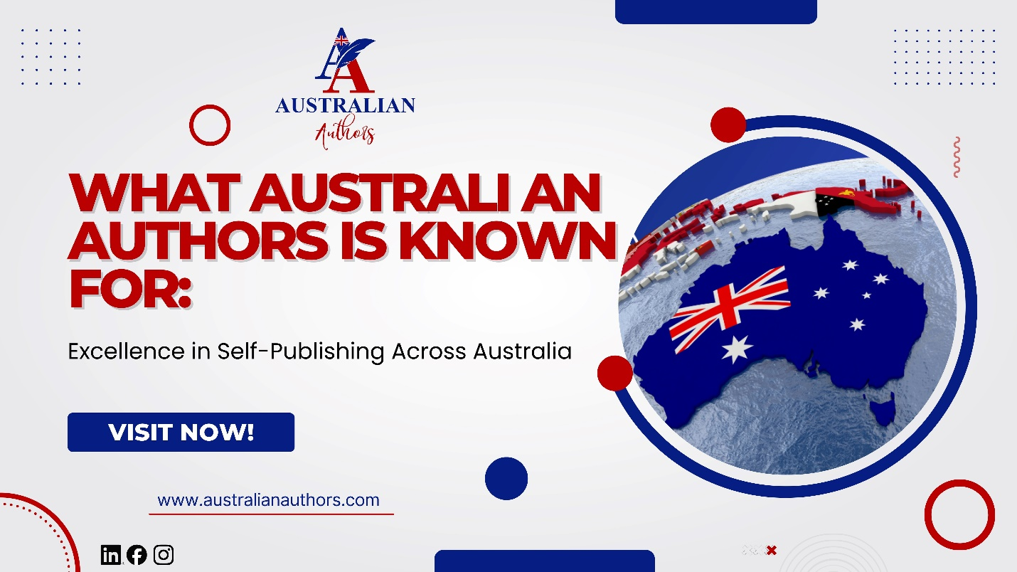
When Australian writers search for a trusted publishing partner, one question always comes up: “What is this company really known for?” That is a fair question. So let me answer it directly. What Australian Authors is known for is quality self-publishing support that actually delivers results for Australian writers.
We have built our reputation in Sydney and right across the country by consistently helping authors produce professional books that look good, read well, and sell. No empty promises. Just honest guidance, high standards, and real outcomes.

Why Quality Matters More Than Ever in Australia
The Australian book market is growing fast. Readers now expect clean, well-designed books whether they buy on Amazon AU, Booktopia, or in-store at Dymocks. At the same time, many authors feel overwhelmed by the choices available.
That is exactly why what Australian Authors is known for stands out. We focus on excellence at every stage so your book competes confidently with traditionally published titles. We combine local knowledge with professional skills to give you the best possible chance of success.

The Reputation We Have Earned
Over the years, Australian Authors has become known for three things in particular.
First, we deliver exceptional quality without taking away your creative control. You stay the author. We simply provide the expertise you need.
Second, we offer truly end-to-end support. From the first idea through to ongoing promotion, everything happens under one roof here in Sydney. This means faster decisions and smoother communication.
Third, we understand the Australian market deeply. We know how Thorpe-Bowker ISBNs work, how local distributors operate, and what helps books stand out on Amazon AU and Booktopia.

What Clients Say About Our Self-Publishing Excellence
Mark, a non-fiction author from Melbourne, came to us after a frustrating experience with an overseas provider. He needed help with developmental editing and cover design. Within four months his business book was live, beautifully formatted, and already generating sales. He later told us the professional quality made all the difference.
Emma, a fiction writer based in Sydney, wanted a full ghostwriting service for her debut novel. She was amazed at how closely we captured her voice. Her book now sits proudly on Dymocks shelves and continues to receive positive reviews.
These stories are common. What Australian Authors is known for is turning good manuscripts into great books that Australian readers actually enjoy and buy.

The Key Areas Where We Excel
Here is a clear look at the areas where our reputation shines brightest:
- Professional Ghostwriting & Writing Services: We help busy authors bring their ideas to life while keeping their unique voice intact.
- Expert Editing & Proofreading: Our editors polish every sentence so your book feels smooth and professional.
- Stunning Book Cover Design: Covers that catch the eye and match Australian genre expectations.
- Flawless Formatting: Perfect layout for both prints and eBook across all major platforms.
- Smart Marketing & Promotion: Practical strategies that fit Australian budgets and target local readers.
- Full Self-Publishing Support: We handle ISBNs, distribution, and platform uploads so you do not have to.
Writers often tell us this complete approach is refreshing compared with piecing services together from different providers.

How to Recognise True Self-Publishing Excellence
Not all companies deliver the same standard. Here is a simple checklist you can use when evaluating any self-publishing partner:
- Do they share real Australian success stories in your genre?
- Can they explain Thorpe-Bowker and local distribution clearly?
- Do they offer transparent pricing with no hidden fees?
- Are they based in Australia and easy to reach?
- Do they focus on quality at every single stage?
If the answer is yes to most of these, you have likely found a strong partner.

Quick Self-Check: Is Professional Excellence Important to You?
- You want your book to look and read as good as any bookstore title
- You value local Sydney-based support and faster timelines
- You need honest feedback, not just “yes” answers
- You want marketing help that actually fits the Australian market
- You are ready to invest in quality that lasts
Tick three or more? Then you are in the right place.

Excellence Is Our Everyday Standard
What Australian Authors is known for is not just a slogan. It is the daily commitment we make to every writer who trusts us with their story. We keep our standards high because we know how much your book means to you.
Whether you write fiction, non-fiction, memoir, or children’s books, we bring the same care and expertise to your project. Our goal is simple: help you create a book you feel proud to share with family, friends, and readers across Australia.
The best part? You do not have to figure everything out alone. We walk beside you from the first conversation right through to launch and beyond.
Ready to turn your manuscript into a professionally published book that reaches Australian (and global) readers? Book a free consultation with the Australian Authors teams today and receive a personalized self-publishing roadmap.

