Blog 4 (Australian Authors) April 2026
Image alt text me keyword, title and description blog wala use hoga. Main heading H1 hogi yani blog title and subheading h2, and others h3
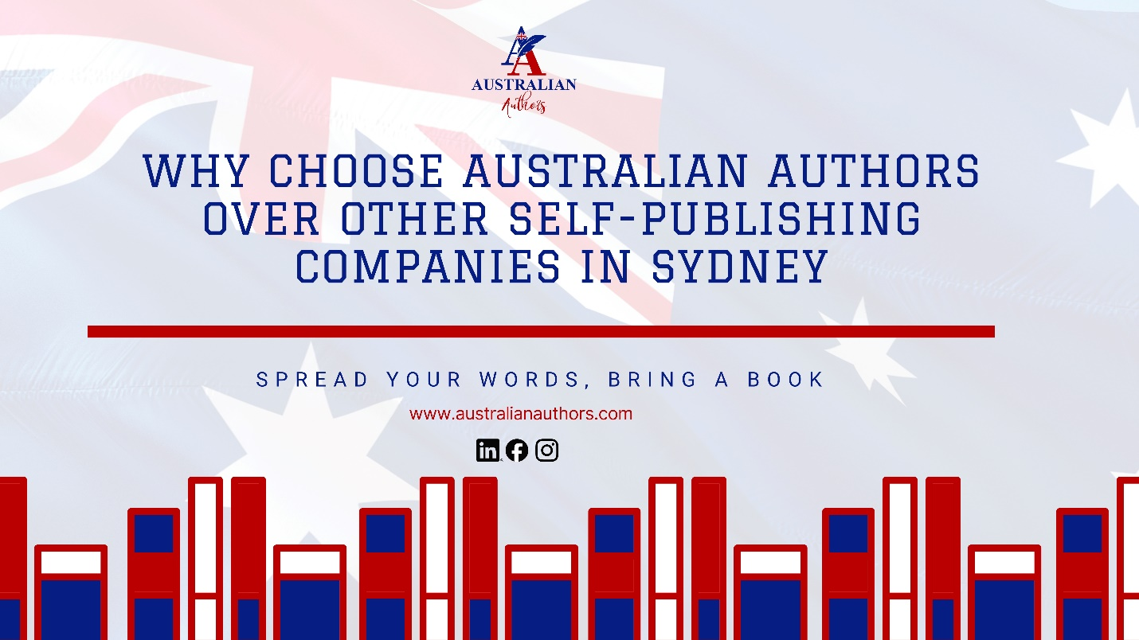
Choosing the right partner to publish your book is one of the most important decisions you will make as an Australian writer. With so many options available, it is natural to ask: why choose Australian Authors Sydney? The simple answer is this: we offer personalized support, deep local expertise, and full-service self-publishing that makes the entire journey simple, affordable, and successful for writers just like you.
We are based right here in Sydney, and that local connection makes a real difference. We understand the Australian market, we respond quickly, and we genuinely care about helping you share your story with pride.

What Makes the Australian Authors of Sydney Different
Many authors feel overwhelmed when they start exploring self-publishing. Some worry about quality. Others fear hidden costs or losing control of their work.
Why choose Australian Authors Sydney? Because we remove those worries. We combine professional standards with a friendly, author-first approach. You keep full creative control while we handle the complex parts with care and transparency.
We know the realities of the Australian publishing world from securing Thorpe-Bowker ISBNs to getting your book listed on Booktopia, Dymocks, and Amazon AU. Our Sydney team delivers faster timelines and more personal support than overseas providers can offer.

Real Reasons Australian Writers Choose Us
Here are the main benefits writers tell us they value most:
- Local Sydney Expertise Our team lives and works in Sydney. We understand Australian readers, distribution networks, and market trends. You get advice tailored to our country, not generic overseas guidance.
- Personalized Support Every Step You work with dedicated professionals who learn about your book and your goals. No automated replies or faceless processes, just real people who answer your questions promptly.
- Full-Service Convenience From ghostwriting and editing to cover design, formatting, publishing, and marketing, everything is under one roof. You do not need to chase multiple suppliers.
- Transparent Pricing We show clear costs upfront so there are no surprises. Many authors find our packages more affordable than they expected while still receiving premium quality.
- Proven Track Record We have helped hundreds of Australian authors publish successfully across fiction, non-fiction, memoir, and more.

Stories from Authors Who Chose Us
Take Lisa, a first-time author from Sydney’s Inner West. She had a completed manuscript but felt lost with formatting and marketing. After choosing Australian Authors Sydney, her book was professionally edited, designed, and launched on Amazon AU and Booktopia within five months. She now receives regular royalties and glowing reviews.
Or consider David, a business coach based in Parramatta. He needed ghostwriting support because of his busy schedule. He chose us because of our local presence and clear process. His book is now helping him attract new clients and establish his authority.
These are not isolated cases. They reflect why we choose Australian Authors Sydney because we turn publishing dreams into reality with less stress and better results.

How We Compare to Other Options
When writers ask why choose Australian Authors Sydney, they often want an honest comparison. Here is the difference in plain terms:
- Traditional publishing can take years and offers limited control.
- Overseas self-publishing companies may be cheaper but often lack local knowledge and quick support.
- DIY approaches save money initially but frequently cost more in time, frustration, and poor-quality results.
We sit in the sweet spot of professional quality with the speed and personal touch that only a Sydney-based team can provide.

Quick Decision Checklist – Is the Australian Authors Sydney Right for You?
- You want a publishing partner based in Australia who understands local platforms
- You value clear communication and fast responses
- You need professional results without losing creative control
- You prefer transparent pricing and no hidden fees
- You are ready to publish your book this year, not in two or three years
If you ticked three or more boxes, we should have a friendly chat about your project.

The Australian Authors Sydney Advantage
Why choose Australian Authors Sydney comes down to one core promise: we make self-publishing feel achievable and enjoyable. You focus on your strengths as a writer while we handle the rest with care and expertise.
Whether you are writing fiction set in the Australian landscape, a heartfelt memoir, or a practical guide to help others, we bring the same dedication to your book. Our goal is simple help you create a book you are proud to see on shelves and screens across the country.
You have already invested time and heart into your manuscript. Now give it the professional support it deserves from a team that truly understands Australian authors.
Ready to turn your manuscript into a professionally published book that reaches Australian (and global) readers? Book a free consultation with the Australian Authors team today and receive a personalized self-publishing roadmap.

